**Predicting the Improvement of Neighborhoods**

**Finding Better Place to Open a Restaurant**

Rajib Mukhopadhyay

June, 21 2019

1. **Introduction:**

Delhi and Kolkata are two major cities in India. These two cities become a centre of attention for residential, job employment, tourism, education, shopping and sports activity. Both cities are well known in India and all over the world, and become the top choice for local and foreign communities.

Information about these two cities:

* **Delhi**, officially the National Capital Territory of Delhi (NCT), is a city and a union territory of India containing New Delhi, the capital of India. It is bordered by Haryana on three sides and by Uttar Pradesh to the east. The NCT covers an area of 1,484 square kilometres (573 sq. mi). According to the 2011 census, Delhi's city proper population was over 11 million, while the whole NCT's population was about 16.8 million. Delhi's urban area is now called Central National Capital Region (CNCR) and had an estimated 2016 population of over 26 million people, making it the world's third-largest urban area according to United Nations. Delhi is located in Northern India, at 28.61°N 77.23°E. Delhi is the largest commercial centre in northern India. Delhi has one of India's largest and fastest growing retail industries manufacturing also grew considerably as consumer goods companies established manufacturing units and headquarters in the city. Delhi's large consumer market and the availability of skilled labour has also attracted foreign investment. As India's national capital and centuries old Mughal capital, Delhi influenced the food habits of its residents and is where Mughlai cuisine originated. Along with Indian cuisine, a variety of international cuisines are popular among the residents. The dearth of food habits among the city's residents created a unique style of cooking which became popular throughout the world, with dishes such as Kebab, biryani, tandoori.

(Source: <https://en.wikipedia.org/wiki/Delhi>)

* **Kolkata**, also known as Calcutta, is the capital of the Indian state of West Bengal. Located on the east bank of the Hooghly River approximately 75 kilometres (47 mi) west of the border with Bangladesh, it is the principal commercial, cultural, and educational centre of East India, while the Port of Kolkata is India's oldest operating port and its sole major riverine port. The city is widely regarded as the "cultural capital" of India, and is also nicknamed the "City of Joy". According to the 2011 Indian census, it is the seventh most populous city; the city had a population of 4.5 million, while the suburb population brought the total to 14.1 million, making it the third-most populous metropolitan area in India. In 1712, the British completed the construction of Fort William, located on the east bank of the Hooghly River to protect their trading factory. Flexible production has been the norm in Kolkata, which has an informal sector that employs more than 40% of the labour force.[20] One unorganised group, roadside hawkers, generated business worth ₹ 87.72 billion (US$ 2 billion) in 2005. Kolkata is known for its literary, artistic, and revolutionary heritage; as the former capital of India, it was the birthplace of modern Indian literary and artistic thought.

(Source: <https://en.wikipedia.org/wiki/Kolkata>)

**1.1 Description of the Problem and Background Scenario:**

Opening a restaurant, in any major city, is all about location, choice of food habit and communication. However, not every restaurant is suitable for every location. It comes down to a combination of restaurant style, target audience, competitors. If someone can define a restaurant type and identify the target demographic and its most populated areas, to choosing a restaurant location that sets a business up for success. There’s a lot of work, planning and preparation that goes into opening a restaurant. Here are a few tips on how to open a restaurant and some steps need to take in order to achieve the goal.

**1.2 Business Problem:**

Some of the features need to focus which may causes the business problem

* Restaurant Style: The first thing need to decide is what type of restaurant will be suitable for the location. Some categories need to consider:
  1. Type of food.
  2. Service to provide.
  3. Open or close area.
* Target Market: Need to focus on the customers from Indian, Paskistani, Bangladeshhi and Chinese origin. Also be aware of the age group, the location, the amount of money they are willing to spend.
* Competitors: Look at similar businesses in the area and well-renowned restaurants of the same category. Consider the ways in which they market themselves and the service they provide.
* Prepare Menu: The menu is the core of any restaurant. It’s important to get it right menu, as it’s the deciding factor for customers deliberating a visit. Service without a menu to match may failure in success.
* Location and Premises: There are many factors that will contribute to where the premises to be. It can be challenging to find a perfect venue that will factor in all of the conditions. This all depends on location, type of shop and rent cost.

**1.3 Interested Audience:**

I believe this is a relevant challenge with valid questions for anyone moving to start a business in a large city, anywhere in the world. The same methodology can be applied in accordance to demands as applicable. This case is also applicable for anyone interested in exploring starting or locating a new business in any city. This will also give a forecast of the cities necessary requirement so that any one may plan a new business to start with new adventure.

1. **Data - Acquisition and Cleaning:**

**2.1 Data Source:**

The following data is required to answer the issues of the problem:

* List of boroughs and neighborhoods of the two cities:
  + <https://www.mapsofindia.com/pincode/india/delhi/>
  + <https://www.mapsofindia.com/pincode/india/west-bengal/kolkata/>
* List of boroughs and neighborhoods of the two cities with their geodata (latitude and longitude)
  + using geopy.geocoders library
* List of restaurants and shops with their address location in these two cities.
  + Foursquare (<www.Foursquare.com>) and geopy data to map top venues for Delhi and Kolkata neighborhoods and clustered in groups.
* List of the places of interest for tourist with their location.
  + Foursquare and geopy data to map the location of different hot places, separately and on top of the above clustered map in order to be able to identify the venues.
* Communication areas.
  + Create a map using folium around a radius of 500 around each neighborhoods to visualise the data for better understanding.
* Analysis of these data and find out some best places to start.

**2.1 Data Cleaning:**

The data is retrieve from the source may need to clean and arrange to answer the issues of the problem. This Data downloaded or scraped from multiple sources were combined into different table.

* Join various sets of data to get the specific type of data. Here I get first Delhi district data and with that district data find the location information of Delhi. Joining to data gives actual information related to Delhi location.
* Join latitude longitude information after getting from geocoders in respect of location.
* Missing values need to clean with a default or some common average value.
* Group various keep field to finalised the need to solve the problem. Group the same postal code location for both Delhi and Kolkata city location data.

### Get Neighborhoods information:

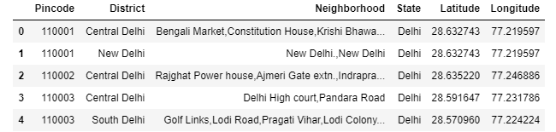

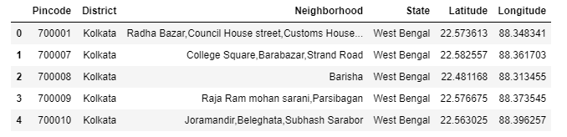

1. **Methodology - Exploratory Data Analysis**

**3.1 Calculation of Target Variable:**

Development area of the two cities continuous changing process by day to day. Venues also change in respect of the two cities. We have a set a target so that we may get the solution in that target.

Here we target the cities Delhi and Kolkata, two most popular city in India.

**3.2 Relationship between two cities**

We will try to make a relationship about the neighborhoods of both the cities and try to find out the venues and hot spot in that areas.

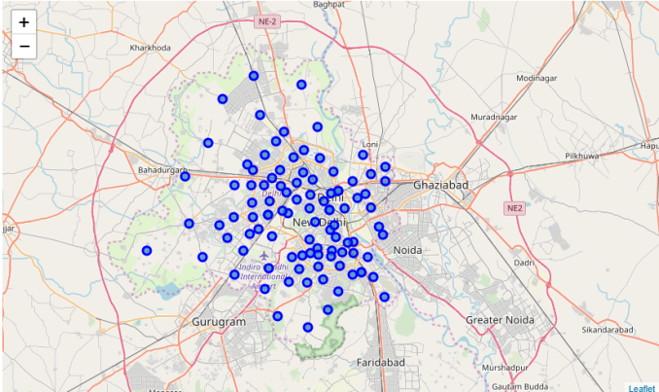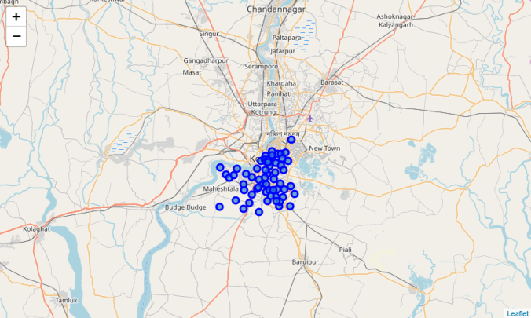

After that, explore to get the most common venue categories in each neighborhood, and then use this feature to group the neighborhoods into clusters.

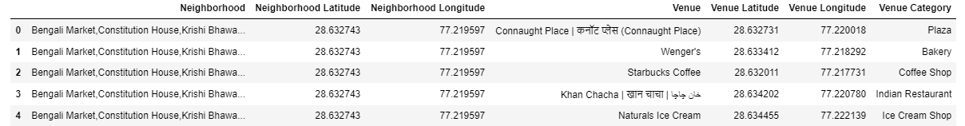

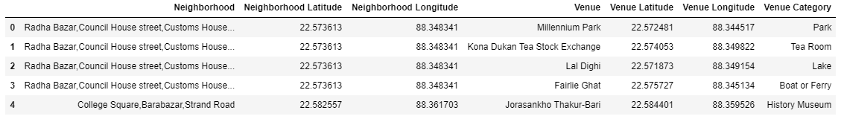

K-means clustering algorithm will be used to complete this task. And also, the Folium library to visualize the neighborhoods in Delhi and Kolkata and their emerging clusters.

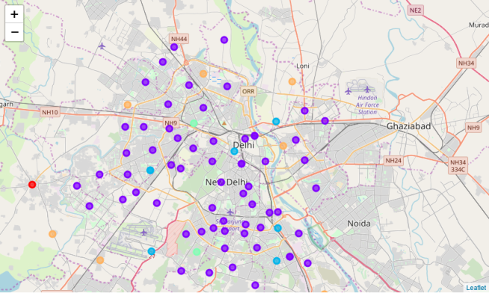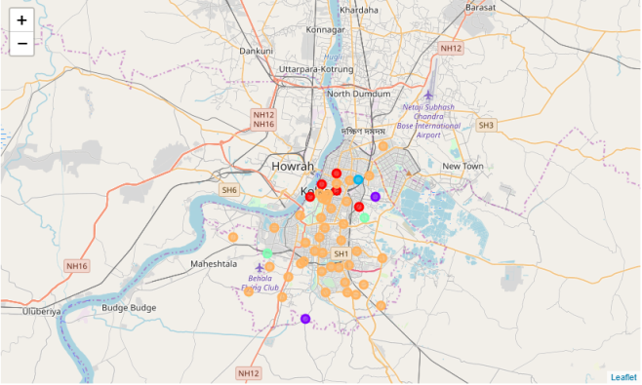

1. **Result**

I analysis with value category related to restaurant of the two cities and the get the result below of top ten common venue from 100 top venue list.

Delhi top 10 common venues:

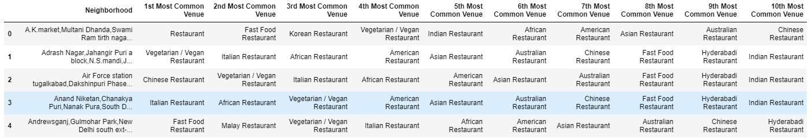

Kolkata top 10 common venues:

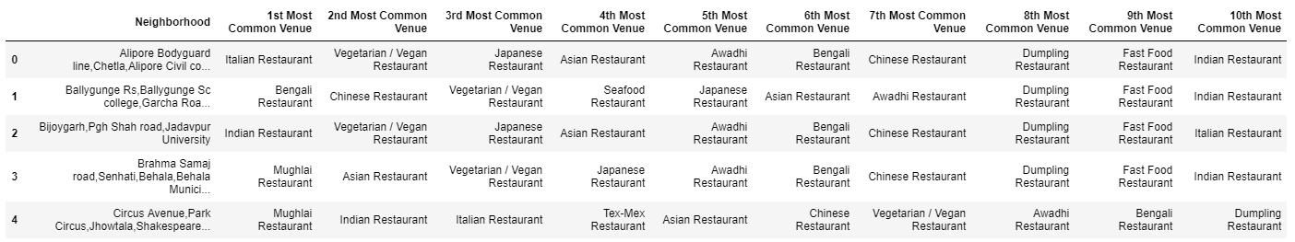

I try to analysis with making a relationship chat with the number of venues in Delhi and Kolkata city.

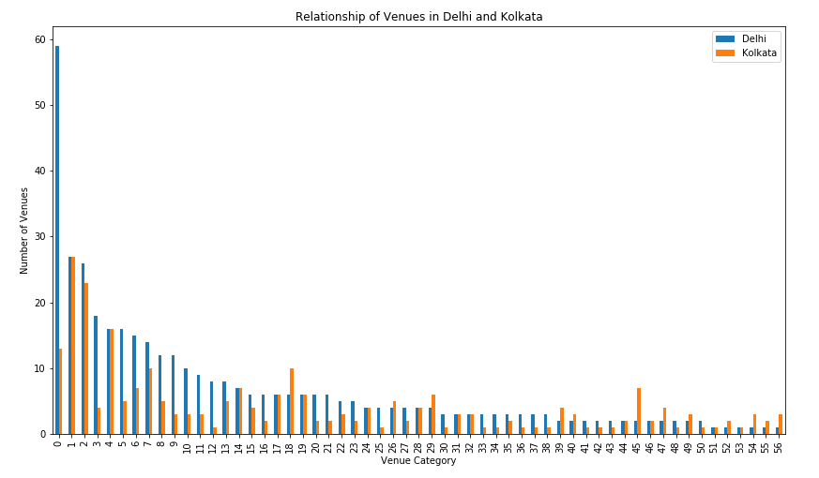

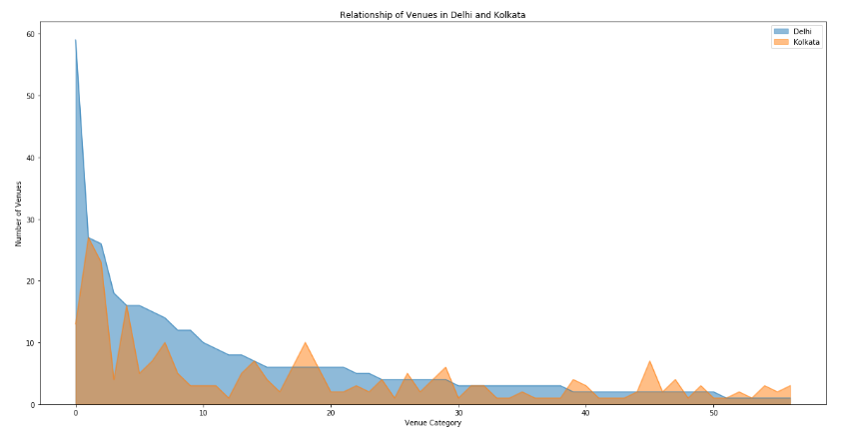

1. **Discussion**

Based on cluster for each city above, I believe that classification for each cluster can be done better with calculation of venues categories (most common) in each city. Referring to each cluster, I can't determine clearly what represent in each cluster by using Foursquare - Most Common Venue data.

However, for this project I assumed by analysing each cluster:

* Delhi is having more demand on Indian Restaurant, Mughlai Restaurant.
* Kolkata is having demand of Chinese Restaurant, Fast Food Restaurant.

,

What is lacking at this point is a systematic, quantitative way to identify and distinguish different district and to describe the correlation most common venues as recorded in Foursquare. The reality is however more complex: similar cities might have or might not have similar common venues. A further step in this classification would be to find a method to extract these common venues and integrate the spatial correlations between different of areas or district.

We believe that the classification we propose is an encouraging step towards a quantitative and systematic comparison of the different cities. Further studies are indeed needed in order to relate the data acquired, and then observe it to more meaningful and objective results.

1. **Conclusions:**

In this study, I analysed the venues between Kolkata and Delhi, the major two cities in India. I identified both cities are similar in some venues also dissimilar in certain venues and for classification based on common venues, again we must have more systematic or quantitative way to identify and declare this. Comparison can be made, but no such method or quantitative data to determine this. We hope in the future, a method to determine it can be establish and explore for references.

1. **References:**

* [Wikipedia](https://en.wikipedia.org)
* [Foursquare API](https://developer.foursquare.com/)
* [Google Map](https://www.google.com/maps/)
* [Maps of India](https://www.mapsofindia.com)
* Link in: <https://www.linkedin.com/post/edit/6548473892913147904>